Sistemas Informáticos (Computer Systems)  
Unit 02. Information representation

short line

Authors: Sergi García, Alfredo Oltra

Updated September 2022

Licencia

**Reconocimiento - No comercial - CompartirIgual** (BY-NC-SA): No se permite un uso comercial de la obra original ni de las posibles obras derivadas, la distribución de las cuales se ha de hacer con una licencia igual a la que regula la obra original.

Nomenclatura

A lo largo de este tema se utilizarán diferentes símbolos para distinguir elementos importantes dentro del contenido. Estos símbolos son:

📖 **Important**

❕ **Attention**

💬 **Interesting**

**INDEX**

**Introduction** **3**

**Piece of information and information** **3**

**Data internal representation** **3**

**Numeral systems** **3**

**Binary code** **4**

**How to convert a decimal number into a binary number** **4**

**How to convert a binary number into a decimal number** **5**

**Maximum number of values to represent** **6**

**Operations with binary numbers** **6**

**Negative numbers** **8**

**Real numbers** **10**

**Boolean algebra** **12**

**Octal** **14**

**How to convert a binary number into octal** **14**

**How to convert an octal number into binary** **14**

**Hexadecimal** **14**

**How to convert binary numbers into hexadecimal** **15**

**How to convert hexadecimal numbers into binary** **15**

**How to convert hexadecimal numbers into octal numbers** **15**

**Alphanumeric Representation** **16**

**Numeric and alphanumeric data.** **16**

**Internal representation** **16**

**Unit system** **17**

**Bibliography** **18**

Unit 02. Information representation

# Introduction

## Piece of information and information

Computers (or more correctly information systems) are machines designed for processing information or, in other words, to get results from the application of operations on a data set. But, what is information? What is a piece of information? And what is an operation?. Take an example:

*The temperature is 30º*

* **Piece of information**: formal representation of a concept, in this case: “30”.
* **Information**: the result of the interpretation of the data: “It's hot”.
* **Operation**: rule applied to get information: “As the temperature is higher than 23, it's hot”.

## Data internal representation

Therefore, we need to store and to handle in computers data and operations. And for that, they need to use the binary code.

❕ **Attention:** all kind of data, both numbers or letters, are stored using this system.

This system is based on the use of only two digits, 0 and 1, unlike the decimal system that uses ten (0, 1, 2, 3, 4, 5, 6, 7, 8, 9). This is because computers only know these two numerical values resulting from the detection or not of some potential, of a number of volts. Thus, a computer knows there's a 0 when the potential measured in an inner member has a value close to 0 volts. Otherwise, it detects a 1.

💬 **Interesting:** in electrical terms, the potential could be assimilated to the strength in which the electric current passes through a wire.

💬 **Interesting:**  in general, values of 1 usually correspond to potential around 3 or 5 volts.

All computer elements handle this numbering and interpretation system of information. It might be said that computers actually know nothing at all. They only know about 0's and 1's and how to perform some basic operations with them (+,-, *...), although faster.

# Numeral systems

A numeral system is a set of **sorted symbols** used to represent quantities. The number of symbols is called **system bases**. In the real world, we are used to using decimal system (base 10) which set of sorted symbols are 0, 1, 2, 3, 4, 5, 6, 7, 8, 9.

Any number, represented in any numeral system, can be split in digits. For instance, 128 can be split in 1, 2, 8 or 34,76 in 3, 4, 7, 6. From these digits and with their position and the system base is possible to get again the number:

We can see that a decimal number can be represented as additions of powers of 10 (the decimal system base).

If we generalize, a number N expressed in a numeral system B would be like:

where:

* N: number to represent
* a: the symbols that our numeral system includes (integers from 0 to B-1)
* The digits before the comma (,)1 are the integer part.
* The digits after the comma (,) are the fractional part.

💬 **Interesting:**  in the English culture, the separation between the decimal part and fractional part is a decimal point (.).

## Binary code

The binary code is a numeral system which system base is 2 and its symbols are 0 and 1.

📖 **Important:** each digit of a binary number is called “bit”, and it is the smallest unit of information, in other words, it is the least that can be represented.

💬 **Interesting:** to avoid confusion, it is usual to indicate the base system number to be represented by a subscript to the right. For example or .

### How to convert a decimal number into a binary number

In general, to convert a decimal number into another base, we have to perform successive divisions of the number by the base. At the end, we have to get the remainders and the last quotient and sorted them in the opposite direction.

Consider the case of convert a decimal into binary with some examples:

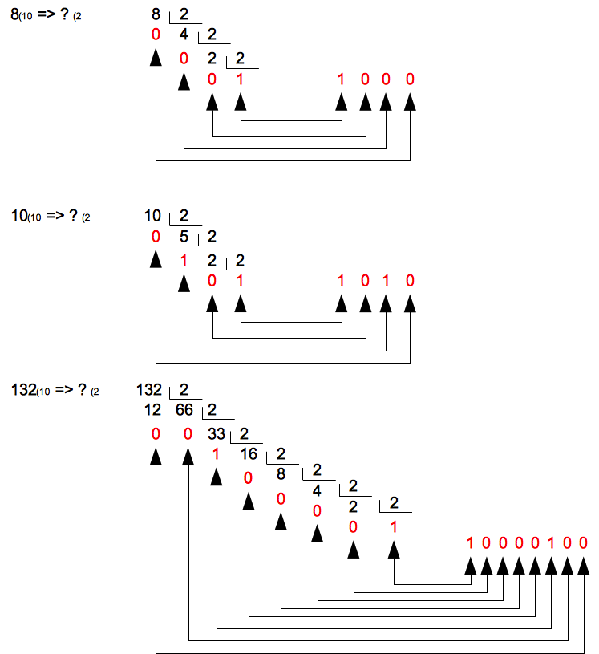



In numbers with fractional part, the process is the same for the integer part, but the fractional part is calculated multiplying by 2 successively and to take the integer part (in this case in right order).

📖 **Important:** the leftmost bit it is called the most significant bit (MSB) and the rightmost bit it is called the least significant bit (LSB).

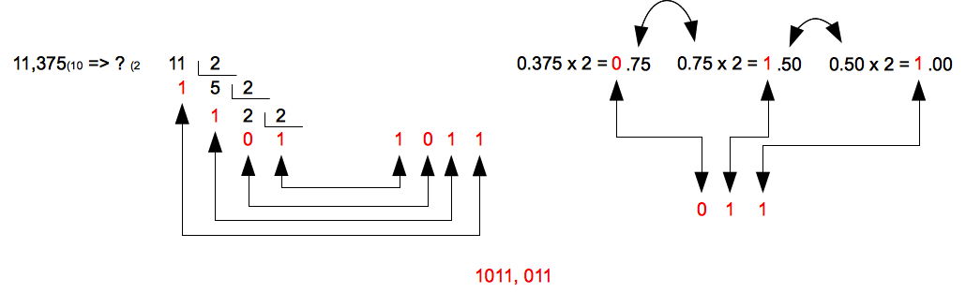

### How to convert a binary number into a decimal number

In this case, the process is very easy. As explained above, a decimal number can be represented as additions of powers of ten.

On the whole, it can convert the value of a number represented in a numeral system B1 into decimal system using the next formula:

N =an-1Bn-1+an-2Bn-2+...+a1B1+a0B0+a-1B-1+...+a-pB-p = ∑ ai Bi

We are going to use it to convert into base 2:

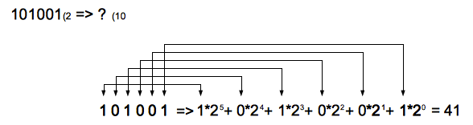

The process involves four steps:

1) To write the binary number figures multiplied by 2.

2) To write a plus sign (+) between each of products.

3) To write an exponent in each 2, starting from zero and from the last number of the integer part (on the far right if there is no fractional part) and increasing it one by one to the left and decreasing to the right.

4)To perform the operation.

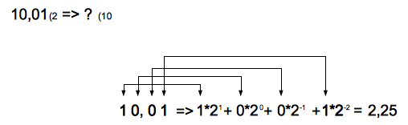

❕ **Attention:** as we will see later, B can be any numeral system.

### Maximum number of values to represent

One typical question when handling a binary number is to know what is the maximum decimal value that can be represented by a certain bit number. The answer is easy: , where n is the number of bits. For instance, with 4 bits we can represent 16 values, from 0 to 15 (0000-1111).

### Operations with binary numbers

Binary addition and subtraction follow the next rules:

**Addition**:

0 + 0 = 0

1 + 0 = 1

0 + 1 = 1

1 + 1 = 0 (carry 1)

**Addition examples:**

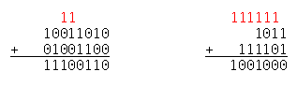

❕ **Attention:** if we want to add two binary numbers which addition is greater than the maximum number to represent, the computer throws an overflow warning. For instance, if we have a computer who works with 8 bits, it can represent from to . If we want to add () plus () we have a problem, because the result is () that is greater than 255, so an overflow occurs. You can see this in this figure:

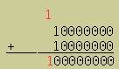

**Subtraction:**

0 - 0 = 0

1 - 0 = 1

0 - 1 = 1 (carry 1 to subtrahend)

1 - 1 = 0

The operations results are the same as their related decimal operations, except for the cases where the result don't have a value in the binary system, that is 1+1, which can not be represented by 2 and 0-1, which can not represent by -1. This is where carry-over is important.

**Subtraction examples:**

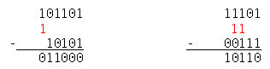

❕ **Attention:** in the subtraction, the carry-over don't add to the minuend, but subtrahend.

**Multiplication**:

0 * 0 = 0

1 * 0 = 0

0 * 1 = 0

1 * 1 = 1

**Division:**

0 / 0 = Undefined

1 / 0 = Boundless

1 / 1 = 1

0 / 1 = 0

Both, multiplication and division, presents no difference from the related operations in decimal, unless the auxiliary operations are performed in binary.

❕ **Attention:** in multiplication, when we add, it may be that we have in the same column more than two 1's. In this case, we perform the additions in groups of two and are going to carry the 1's in the next column.

❕ **Attention:** in division, we start getting in dividend and divisor the same number of figures. If you can not be divided, we try getting one figure more in the dividend.

If the division is possible, then, the divisor can only be contained once in the dividend, that is, the first quotient figure is 1. In this case, the result of multiplying the divisor by 1 is the divisor itself (the value that we will subtract).

**Multiplication example (conversion to several additions):**

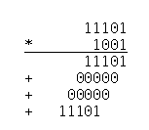

**Division example:**

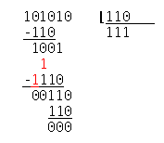

### Negative numbers

When we need to represent a negative binary number, we have several options, although three of them are the most important. This range indicates that the way to express it should be an agreement between two sides: the one that generates the number and the one to read it. If not, the real value to be expressed would be wrong.

**Signed magnitude**

Perhaps it is the easiest approach to understand. The idea is to keep the MSB to indicate the sign of the number: 0 positive, 1 negative. The remaining bits indicate the number value in absolute value. For example:

| **Decimal** | **Binary** | **Positive binary** | **Negative binary** |
| --- | --- | --- | --- |
| 5 | 101 () | 0101) | 1101 (- ) |

As can be seen, we need a bit to indicate the sign, so that what in normal representation values would be 0 to 15 in this case, to use the sign, becomes of -7 to +7 (1111 - 0111).

This system is simple to understand but complex to use when performing mathematical operations. Besides, it has a problem: there are two ways to define the : (+0) and (-0).

**Ones' complement**

The second option also uses the first bit as sign indicator, but in this case the negative number is achieved complemented positive number (changing ones' by zeros and vice versa).

| **Decimal** | **Binary** | **Positive binary** | **Negative binary** |
| --- | --- | --- | --- |
| 5 | 101 () | 0101) | 1010 (- ) |

In this option is required to give the number of bits to encode, in such a way that if in the previous example we use 8 bits to encode:

| **Decimal** | **Binary** | **Positive binary** | **Negative binary** |
| --- | --- | --- | --- |
| 5 | 101 () | 00000101) | 11111010 (- ) |

This method has the same problem that signed magnitude: there are two ways to define the 0 number: : (+0) and (-0).

**Two's complement**

Although ones' complement simplifies the mathematical operations, they do much more with the use of two's complement. That is why it is the most used method.

Two's complement consists in to apply ones' complement and then, to add 1. For instance, two's complement of 5 encoded with 8 bits is:

*→ → (encoded in 8 bits) →*

*→ (1's complement) → (+1)* →

| **Decimal** | **Binary** | **Positive binary** | **Negative binary** |
| --- | --- | --- | --- |
| 5 | 101 () | 00000101) | 11111011 (- ) |

What decimal number represents a number in two's complement?. Easy. We have to preform the same process:

*→ (1's complement) → → (+1) →*

The great advantage of the two's complement method is that it allows subtraction as if they were adds.

This is because subtract two binary numbers is the same as adding to the minuend the complement of the subtrahend.

*() – () → (1's complement) → →*

*→ (+1) 101011 → 101101 + 101011*

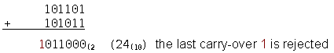

***Excess-K or offset binary***

Depending on the number of bits available, the mid-range is dedicated for negative numbers and the other half (minus 1) to the positives (the zero value is in the middle). The new range will be [-K,K-1], where we can calculate by K = 2n-1.

💬 **Interesting:** there is another version of this method with K = (2n-1 - 1).

Once we have the permissible range, the smallest number is who has all its bits to 0. Let us see an example:

We have 3 bits for representing the number, so we can represent 23 numbers, the range [0,7]. In this case, K will be 23-1 = 22 = 4, so the range with negative numbers will be [-4,3].

The smallest number -4 will be 000 and the biggest 3 will be 111. The complete board will be:

| **-4** | **-3** | **-2** | **-1** | **0** | **1** | **2** | **3** |
| --- | --- | --- | --- | --- | --- | --- | --- |
| 000 | 001 | 010 | 011 | 100 | 101 | 110 | 111 |

If we have a number in Excess-K, and we know its decimal value, we need to subtract the value of the excess to the decimal value. For instance, if n = 8 then K= *→* = 128,

*11001100 → 204 ; 204 - 128 = 76 or 00111100 → 60 ; 60 - 128 = -68*

### Real numbers

When we write a real number in a sheet, we use a decimal comma (or decimal point, it depends on the culture) to distinguish between integer part and fractional part. In a computer, the space to represent this kind of numbers is divided in two areas: one for the integer part and one for the fractional part. There are two ways to denote the size of these areas (fields), and therefore, the comma position: fixed point and floating point.

**Fixed point**

In this notation, we assign a fixed size to the integer part and the fractional part of the number, in other words, a fixed place to the comma.

The advantage is that the process to perform basic operations is the same that integers numbers. However, this method does not take advantage of the capacity of representation format used. For instance, a computer with 8 bits to represent numbers, could use 5 bits for integer part and 3 for fractional part .

In this case the maximum number to represent will be 01111,111 and the minimum (positive) 00000,001. If the decimal comma would be in a floating position, the range of positive numbers tu represent would be 011111111 – 0,0000001

**Floating point**

The range of numbers that can be represented in the fixed point format is insufficient for many applications, particularly for scientific applications, which often use very large and very small numbers. To represent a wide range of numbers using relatively few digits, is well known in the decimal system, the scientific representation or exponential notation. For example, 0,00000025 = 2,5*. In general, for any numbering system, a real number can be expressed as:

*N = M * BE or N = (M;B;E)*

where:

M: mantissa

B: base

E: exponent

The internal representation that makes this format on computers is known as floating point.

For instance, in decimal (B=10) = 0,25975* or (0,25975;10;3) or, in binary code

*→ → 0,10000001111 * → 0,10000001111 * → (0,10000001111;1001)*

The representable numbers range, for a given value of B, is fixed by the number of bits of the exponent E, while the accuracy is determined by the number of bits of M.

**Normalization**

The same real value can be represented in infinite ways by exponential notation. For example, 2,5 can be represented as 0,25*101, 0,025*102,250*10-2, etc. To avoid confusion, we should choose one of these formats as the standard for floating point representation of a real number. The form chosen is called *Normalized form,* and it is one that maintains the highest accuracy in the representation of numbers. This is achieved when the binary point is located immediately to the left of the first significant digit, so that no space is wasted representing no significant digits.

**Example:**

*2,5 represented in normalized form is 0,25\**

*(0,000011101 ; 2 ; 0111) → (0,11101 ; 0011) → Exponent excess-k (0,11101 ; 1011)*

📖 **Important:** in general, to represent negative exponents the excess-k method is used. On the other hand, to represent negative mantissas, a signed magnitude method is used.

**More examples:**

*(100,11110 ; 2 ; 0010) → (0,10011110 ; 2 ; 0101) → Exponent excess-k (0,10011110 ; 1101)*

*(101,001 ; 2 ; 0100) → (0,1010010 ; 2 ; 0111) → Exponent excess-k (0,10011110 ; 1111)*

**IEEE754**

The most popular format for representing floating points in binary was developed by the Institute of Electrical and Electronics Engineers (IEEE) and it is called the IEEE754. This format can represent special cases such as infinite values and undefined results, called NaN (Not a Number) results. It proposes 3 formats: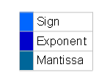

**Half precision:** it uses 16 bits



It uses 16 bits: One bit for the sign, 5 for the exponent, 10 for the mantissa.

**Simple precision:**



It uses 32 bits: One bit for the sign, 8 for the exponent, 23 for the mantissa.

**Double precision:**



It uses 64 bits: One bit for the sign, 11 for the exponent, 55 for the mantissa.

📖 **Important:** all three formats use normalized mantissa, so the first bit on the left hand of the mantissa will be a 1 (the first significant digit have to be a 1). Because of this, **these formats do not encode this 1 in the mantissa, although it is taken into account when operating** with the number. In other words, in these formats the MSB is on the left of the decimal comma, and they only save the bits on the right side.

📖 **Important:** to represent the exponent, the standard uses the Excess-K method with K = -1.

### Boolean algebra

Besides mathematical operations (+,-,*/), on binary numbers can apply boolean or logical operations: AND, OR, XOR, NOT, etc.

📖 **Important:** to better understand these operations, it is worth to name **1 as “true”** and **0 as “false”.**

**NOT**:

It can be represented in various ways: NOT, ¬

NOT 0 = 1

NOT 1 = 0

**AND**:

It can be represented in various ways: AND, Y, ^, *

0 AND 0 = 0

1 AND 0 = 0

0 AND 1 = 0

1 AND 1 = 1

In other words, the result will be “true” (1) only when both digits were “true”. As can be seen, the result is the same as the multiplication.

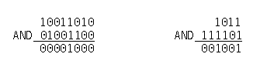

**OR:**

It can be represented in various ways: OR, O, v

0 OR 0 = 0

1 OR 0 = 1

0 OR 1 = 1

1 OR 1 = 1

In this case, the result will be “true” as soon as one of the digits was “true”.

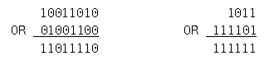

**XOR:**

0 XOR 0 = 0

1 XOR 0 = 1

0 XOR 1 = 1

1 XOR 1 = 0

In this case, the result will be “true” when one and only one of the digits were “true”.

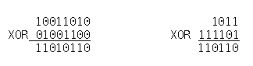

## Octal

Beside binary, there are two other interesting numeral systems when working on issues related to information technology: the octal and hexadecimal. This is because from them are easy to convert to binary.

The octal is a numeral system with a system base equal to 8 (symbols 0, 1, 2, 3, 4, 5, 6, 7). Its base is an exact power of binary system base =8 or, in other words, with three binary digits (with three bits) we can represent all the octal digits.

| **Decimal** | **Binary** | **Octal** |
| --- | --- | --- |
| 0 | 000 | 0 |
| 1 | 001 | 1 |
| 2 | 010 | 2 |
| 3 | 011 | 3 |
| 4 | 100 | 4 |
| 5 | 101 | 5 |
| 6 | 110 | 6 |
| 7 | 111 | 7 |

### How to convert a binary number into octal

The process lies in creating groups of threes bits, starting on the right hand, and replace them for the related octal value

*=> Groups of three elements 1 101 011 =>*

### How to convert an octal number into binary

The process is reversed to the previous: it is converted to binary each of the numbers of octal number

*=> Groups of three elements 111 100 000 010 =>*

## Hexadecimal

Its system base is 16. As the number of symbols used in the system is greater than 10, 6 characters must be used, in this case from A to F. Thus, the ordered set of symbols is: 0, 1, 2, 3, 4, 5, 6, 7, 8, 9, A, B, C, D, E, F.

| **Decimal** | **Binary** | **Hexadecimal** |
| --- | --- | --- |
| 0 | 0000 | 0 |
| 1 | 0001 | 1 |
| 2 | 0010 | 2 |
| 3 | 0011 | 3 |
| 4 | 0100 | 4 |
| 5 | 0101 | 5 |
| 6 | 0110 | 6 |
| 7 | 0111 | 7 |
| 8 | 1000 | 8 |
| 9 | 1001 | 9 |
| 10 | 1010 | A |
| 11 | 1011 | B |
| 12 | 1100 | C |
| 13 | 1101 | D |
| 14 | 1110 | E |
| 15 | 1111 | F |

### How to convert binary numbers into hexadecimal

The process is similar to the binary-octal process, except in this case groups are in fours.

*=> Groups of four elements 110 1011 =>*

### How to convert hexadecimal numbers into binary

The process is reversed to the previous: it is converted to binary each of the numbers of octal number

*=> Groups of four elements 0111 1111 0000 1010 =*

### How to convert hexadecimal numbers into octal numbers

We convert into binary and group the bits in fours or threes, whichever is the numeral system destination

*=> Groups of four elements 110 1011 => =>*

*=> Groups of three elements 1 101 011 =>*

📖 **Important:** the conversion between octal or hexadecimal and decimal or vice versa, can be performed following the methods to convert between binary and decimal, but multiplying by power of 8 or 16 or dividing by these numbers and to get the remainders (in hexadecimal if the remainder is greater than 9 we get its related values A to F).

However, it is usually more practical to perform directly conversion into binary and then, convert into the system requested.

# Alphanumeric Representation

## Numeric and alphanumeric data.

A data is numeric if it is possible to perform mathematical operations. In contrast, a data is alphanumeric If you can NOT perform mathematical operations on it:

* **Numeric** : how old are you? 45.
* **Alphanumeric**: What is your name? ”Roberto”.

In order to clearly differentiate between the two types of data, it is common to use single or double quotes to indicate that data is alphanumeric.

It is usual to think that numeric data are numbers and alphanumeric data are only letters. But this is not correct. For instance:

* What is your address? “Avenida de las Palmeras, 34”
* What is your mobile number? “555341273” => (It is not a number!)

In the first case, **“Avenida de las Palmeras, 34”**, is composed of letters and numbers, and in the second, “**555341273”**, it is formed only by numbers, but is not operable as a number because it is a string (it makes no sense to add or multiply two phone numbers).

## Internal representation

Alphanumeric characters to represent computers rely on tables, such that each of the table entries (each number) corresponds to an alphanumeric symbol.

Throughout the history of computing, there have been several tables that have always been characterized by the number of bits used to represent each character. One of the best examples in the ASCII table. The number of bits is 7, which left room for 128 characters (=128)

As can be seen in the following table, each number is related with a character. For example, is a "I", is a "i" or is a "2". The first entries are reserved for non-printable characters, those that are not visible, such as tabulator () or carriage return ().

The space is also a character: .

The problem of this table is its limited space. As you can see, it has room for all the Latin spellings used in Anglo-Saxon languages, but we can not find spellings like the “ñ”, “ç” or accented vowels. Therefore, the extended ASCII table of 8 bits (256 characters) was created. This new table can incorporate all of Latin spellings plus some graphic symbols.

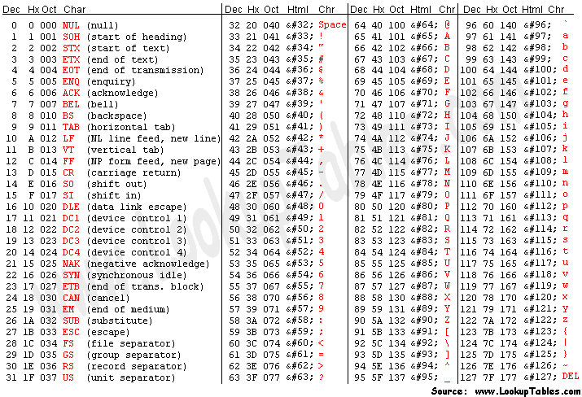

📖 **Important:** today, the ASCII tables are almost obsolete. The expansion of the Internet and globalization make necessary tables that incorporate not only Latin characters, but Chinese, Arabic, Korean, Russian, Hebrew, etc.

# Unit system

As discussed above, the bit is the smallest unit of information. Today we do not work at bit level, but in groups of bits (in the previous section we have seen that a character is encoded using 7 or 8 bits).

Because inside the computer everything is in binary code, an easy way to handle groups is to use some value that is a power of 2, being the most basic 23 = 8. A group of 8 bits is called a byte.

Today it is not usual to use the byte group, but some multiple of it: Kilobyte (kB), Megabyte (MB), Gigabyte (GB), Terabyte (TB), etc.

In the International System these multiples are powers of 10 (they are based on the decimal system), but in computing powers of 2 are used. However, the trend is to use the International System, although it should be noted that the values are similar but not the same.

We use two different kinds of words to differentiate between the system units. When we talk about kilobyte we refer to the decimal system and when we talk about kibibytes to the binary system.

The equivalences can be seen in the following table:

| **Name International System** | **International System** | **Binary** | **Name Binary** |
| --- | --- | --- | --- |
| Kilobyte (kB) | bytes = 1000 bytes | bytes = 1024 bytes | Kibibyte (kiB) |
| Megabyte (MB) | bytes = 1000 kB | bytes = bytes | Mebibyte (MiB) |
| Gigabyte (GB) | bytes = 1000 MB | bytes = bytes | Gibibyte (GiB) |
| Terabyte (TB) | bytes = 1000 GB | bytes = bytes | Tebibyte (TiB) |
| Petabye (PB) | bytes = 1000 TB | bytes = bytes | Pebibyte (PiB) |
| Exabyte (EB) | bytes = 1000 PB | bytes = bytes | Exbibyte (EiB) |
| Zetabyte (ZB) | bytes = 1000 EB | bytes = bytes | Zebibyte (ZiB) |

📖 **Important:** although is usually used indifferently and, even today is more common International System, the values that are represented are different: 1 MB are 1,000,000 bytes (one million bytes), while 1 MiB are 1,048,576 bytes.

❕ **Attention:** it is important to differentiate between kB and kb. The first refers to kilobyte, while the second kilobit, 8 times less.

💬 **Interesting:** although most of the names and abbreviations of multiples have capital letters, the kilo is defined with a lowercase.

# Bibliography

[1] Wikipedia. Signed Number Representations

<https://en.wikipedia.org/wiki/Signed_number_representations>

[2] Wikipedia. Signed Number Representations

<https://en.wikipedia.org/wiki/Signed_number_representations>